**Hands on 1**

**Spring Data JPA - Quick Example**   
  
**Software Pre-requisites**

* MySQL Server 8.0
* MySQL Workbench 8
* Eclipse IDE for Enterprise Java Developers 2019-03 R
* Maven 3.6.2

**Install and Configure MySQL**

CREATE DATABASE ormlearn;

USE ormlearn;

CREATE TABLE country (

co_code VARCHAR(2) PRIMARY KEY,

co_name VARCHAR(50)

);

INSERT INTO country VALUES ('IN', 'India');

INSERT INTO country VALUES ('US', 'United States of America');

Configure Database in application.properties

# Logging

logging.level.org.springframework=info

logging.level.com.cognizant=debug

logging.level.org.hibernate.SQL=trace

logging.level.org.hibernate.type.descriptor.sql=trace

# MySQL Configuration

spring.datasource.driver-class-name=com.mysql.cj.jdbc.Driver

spring.datasource.url=jdbc:mysql://localhost:3306/ormlearn

spring.datasource.username=root

spring.datasource.password=root

# Hibernate

spring.jpa.hibernate.ddl-auto=validate

spring.jpa.properties.hibernate.dialect=org.hibernate.dialect.MySQL5Dialect

**Create Country Entity Class**

package com.cognizant.ormlearn.model;

import javax.persistence.*;

@Entity

@Table(name = "country")

public class Country {

@Id

@Column(name = "co_code")

private String code;

@Column(name = "co_name")

private String name;

// Getters and Setters

public String getCode() { return code; }

public void setCode(String code) { this.code = code; }

public String getName() { return name; }

public void setName(String name) { this.name = name; }

@Override

public String toString() {

return "Country [code=" + code + ", name=" + name + "]";

}

}

**Create Repository Interface**

package com.cognizant.ormlearn.repository;

import org.springframework.data.jpa.repository.JpaRepository;

import org.springframework.stereotype.Repository;

import com.cognizant.ormlearn.model.Country;

@Repository

public interface CountryRepository extends JpaRepository<Country, String> {

}

**Create Service Class**

package com.cognizant.ormlearn.service;

import java.util.List;

import org.springframework.beans.factory.annotation.Autowired;

import org.springframework.stereotype.Service;

import org.springframework.transaction.annotation.Transactional;

import com.cognizant.ormlearn.model.Country;

import com.cognizant.ormlearn.repository.CountryRepository;

@Service

public class CountryService {

@Autowired

private CountryRepository countryRepository;

@Transactional

public List<Country> getAllCountries() {

return countryRepository.findAll();

}

}

**Modify Main Class**

package com.cognizant.ormlearn;

import java.util.List;

import org.slf4j.Logger;

import org.slf4j.LoggerFactory;

import org.springframework.boot.SpringApplication;

import org.springframework.boot.autoconfigure.SpringBootApplication;

import org.springframework.context.ApplicationContext;

import com.cognizant.ormlearn.model.Country;

import com.cognizant.ormlearn.service.CountryService;

@SpringBootApplication

public class OrmLearnApplication {

private static final Logger LOGGER = LoggerFactory.getLogger(OrmLearnApplication.class);

private static CountryService countryService;

public static void main(String[] args) {

ApplicationContext context = SpringApplication.run(OrmLearnApplication.class, args);

LOGGER.info("Inside main");

countryService = context.getBean(CountryService.class);

testGetAllCountries();

}

private static void testGetAllCountries() {

LOGGER.info("Start");

List<Country> countries = countryService.getAllCountries();

LOGGER.debug("countries={}", countries);

LOGGER.info("End");

}

}

**Output**

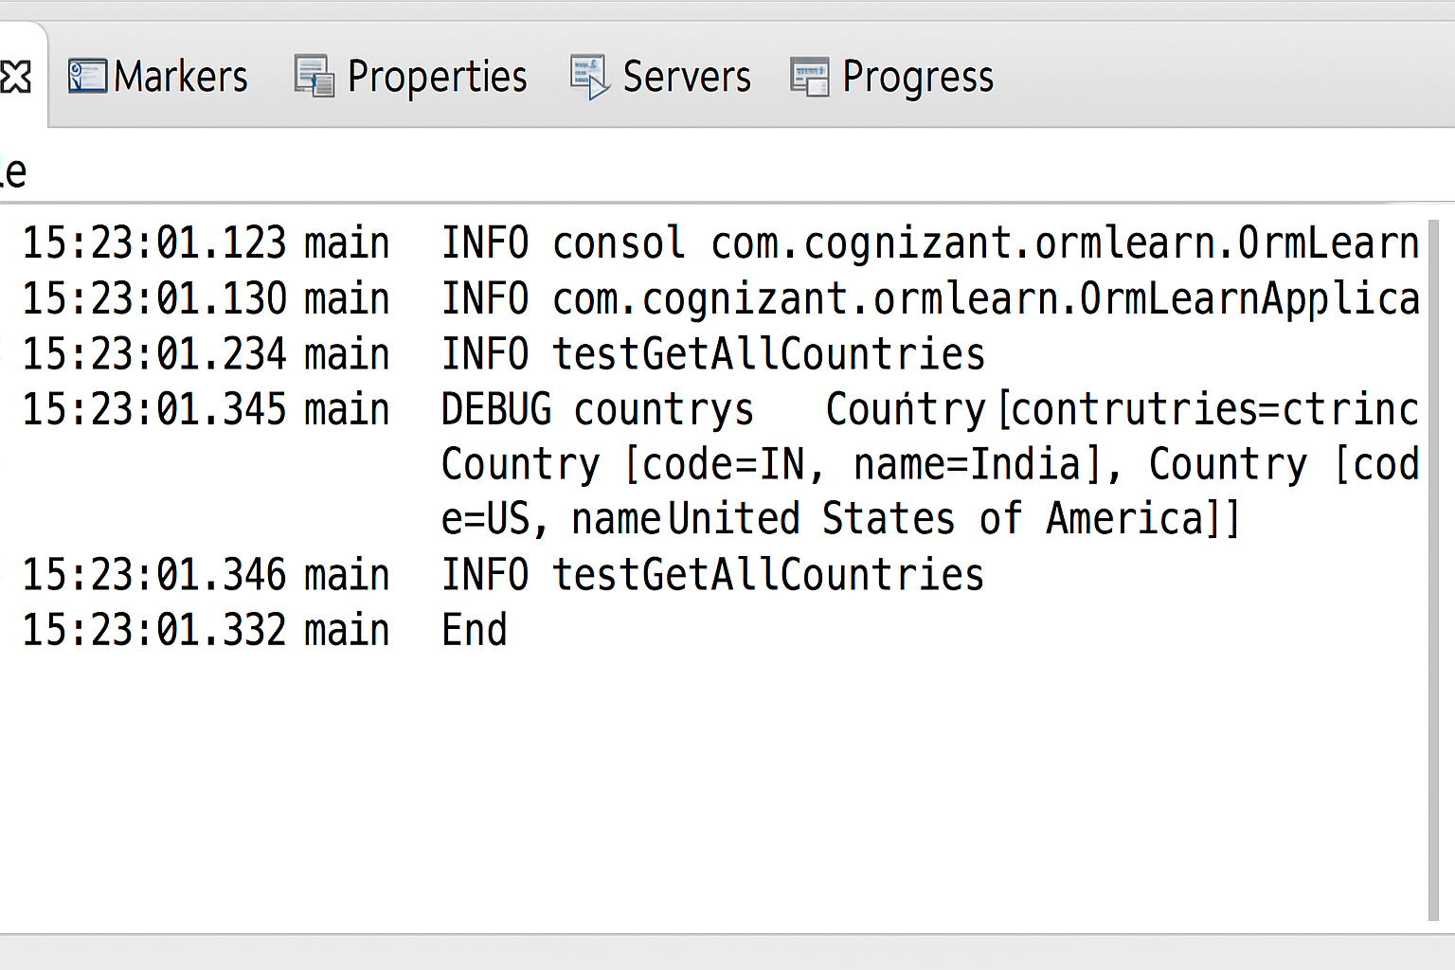

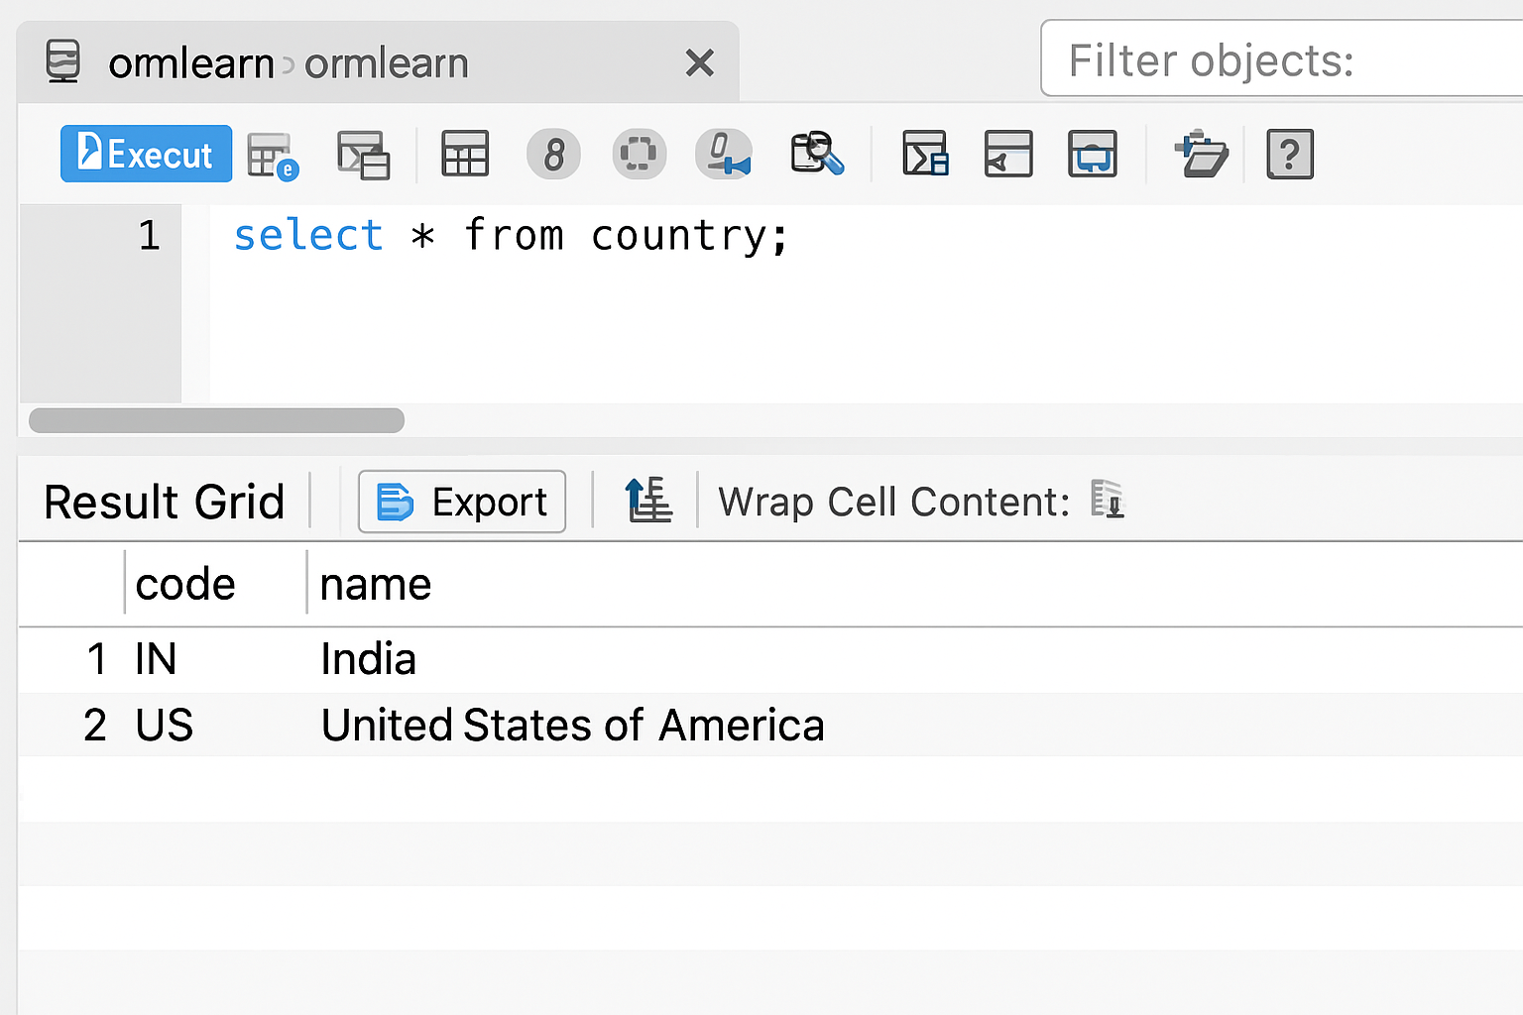

**Hands on 4**

**Difference between JPA, Hibernate and Spring Data JPA**

**1. Java Persistence API (JPA)**

* **What it is:**  
  A **specification** (standard) defined by **JSR 338** for managing relational data in Java applications.
* **Key points:**
  + Defines APIs and annotations (@Entity, @Table, etc.)
  + Doesn't provide actual implementation — only rules/guidelines.
  + You need a provider like Hibernate to actually make it work.
* **Example:**  
  You define entities and interfaces using JPA annotations, but it won't persist anything unless you have Hibernate or EclipseLink.

**2. Hibernate**

* **What it is:**  
  A **popular ORM (Object Relational Mapping)** tool that **implements JPA** specification.
* **Key points:**
  + Manages database sessions, queries, and transactions.
  + Offers features beyond JPA (e.g., caching, lazy loading).
  + Requires boilerplate code (sessions, transactions).
* **Code Example:**

java

public Integer addEmployee(Employee employee) {

Session session = factory.openSession();

Transaction tx = null;

Integer employeeID = null;

try {

tx = session.beginTransaction();

employeeID = (Integer) session.save(employee);

tx.commit();

} catch (HibernateException e) {

if (tx != null) tx.rollback();

e.printStackTrace();

} finally {

session.close();

}

return employeeID;

}

**3. Spring Data JPA**

* **What it is:**  
  A **Spring Framework abstraction** over JPA — simplifies and automates much of the repetitive CRUD boilerplate code.
* **Key points:**
  + Built on top of JPA (uses Hibernate underneath).
  + No need to write SQL or session code.
  + Just define interface methods; Spring auto-generates implementations.
  + Supports pagination, sorting, custom queries via JPQL/native SQL.
* **Code Example:**

EmployeeRepository.java

public interface EmployeeRepository extends JpaRepository<Employee, Integer> {}

EmployeeService.java

@Service

public class EmployeeService {

@Autowired

private EmployeeRepository employeeRepository;

@Transactional

public void addEmployee(Employee employee) {

employeeRepository.save(employee);

}

}